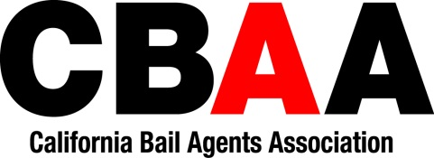
Please fill out this registration form and email to brandie@cbaa.com. Then go to https://cbaa.com/product-category/cbaa-education/ to make your payment.
Correspondence Courses - (Continuing Education):
Please Circle which option you’d like:
Option 1: All 12 Courses (Cost: $198.00)
Option 2: Courses 1-6 (Cost: $99.00)
Option 3: Courses 7-12 (Cost: $99.00)
Please bring a pen, highlighter, and notebook.
Name: | Submitter Name (if different from student):
Students Email: (Course will be emailed over to you within 24 hours) | Bail Agency Name:
Students Address: | Bail Agency’s address:
City, State, Zip: | City, State, Zip
Student’s Phone #: | Agency’s Phone #:
Social Security Number: | Bail Agent License #:

- I hereby authorize CBAA to send me via e-mail, information regarding its education program, legislative program, convention, and other pertinent information regarding the bail.
- CBAA does not rent or sell its Membership data.
- Auditing a course will not include a certificate of completion. You will need to register for the course that includes certification.
- By submitting this form, you have read and understand the policies written above.
Contact Brandie Mitchell- Phone: 888.391.0456 Ext 106 and Fax: 888.390.8359 or email: brandie@cbaa.com if you have any questions.

